Question 3: (2.0 Point)
Design the form which at running might look something like figure below (0.5 Point)
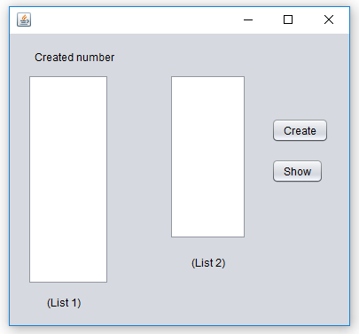
If a user click on the button “Create”, then random numers are created sequentially in each second and added to (List 1). Now if you select numbers in (List 1) and click “Show” then selected numbers sequentially added into (List 2) in every second.
